Handout no. 6

|  |  |
| --- | --- |
| **Name** |  |
| **Reg. No** |  |
| **Marks/Grade** |  |

**EXPERIMENT # 6**

**Parameter setting of Definite Time Overcurrent Relay**

**Objective:**

At the end of this lab session students will be able to

* Use De Lorenzo power system Protection kits.
* Implement Definite Time Overcurrent Relayby using De Lorenzo power system Protection kits.
* Relay behaviour in three phase systems for Overcurrent conditions.
* Determination of resetting ratio

**Introduction:**

A relay is usually an electromechanical device that is actuated by an electrical current. The current flowing in one circuit causes the opening or closing of another circuit. Relays are like remote control switches and are used in many applications because of their relative simplicity, long life, and proven high reliability. Relays are used in a wide variety of applications throughout industry, such as in telephone exchanges, digital computers and automation systems. Highly sophisticated relays are utilized to protect electric power systems against trouble and power blackouts as well as to regulate and control the generation and distribution of power. In the home, relays are used in refrigerators, washing machines and dishwashers, and heating and air-conditioning controls.

Although relays are generally associated with electrical circuitry, there are many other types, such as pneumatic and hydraulic. Input may be electrical and output directly mechanical. All relays contain a sensing unit, the electric coil, which is powered by AC or DC current. When the applied current or voltage exceeds a threshold value, the coil activates the armature, which operates either to close the open contacts or to open the closed contacts. When a power is supplied to the coil, it generates a magnetic force that actuates the switch mechanism

**Apparatus:**

* 1DL 1013T1 Experimentation Transformer
* 1DL 2108T14 Definite time Overcurrent Relay
* 1 DL 2109T2A5 Moving iron Ammeter
* 1 DL Buz Acoustic continuity tester

**Overcurrent Relay:**

In an over current relay, there would be essentially a current coil. When normal current flows through this coil, the magnetic effect generated by the coil is not sufficient to move the moving element of the relay, as in this condition the restraining force is greater than deflecting force. But when the current through the coil increased, the magnetic effect increases, and after certain level of current, the deflecting force generated by the magnetic effect of the coil, crosses the restraining force, as a result, the moving element starts moving to change the contact position in the relay. Although there are different types of over current relays but basic working principle of over current relay is more or less same for all.

**Definite Time Overcurrent Relay**

This relay is created by applying intentional time delay after crossing pick up value of the current. A definite time over current relay can be adjusted to issue a trip output at definite amount of time after it picks up. Thus, it has a time setting adjustment and pick up adjustment.

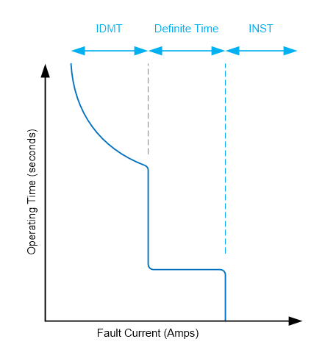

*Time-current characteristics curves for IDMT, DTOC and INST*

**Indications:**

ON: Green LED, supply on

A: Red LED, set point has reached

Cross: RED LED, Relay operate

**Definite Time Overcurrent Relay Basic Diagram:**

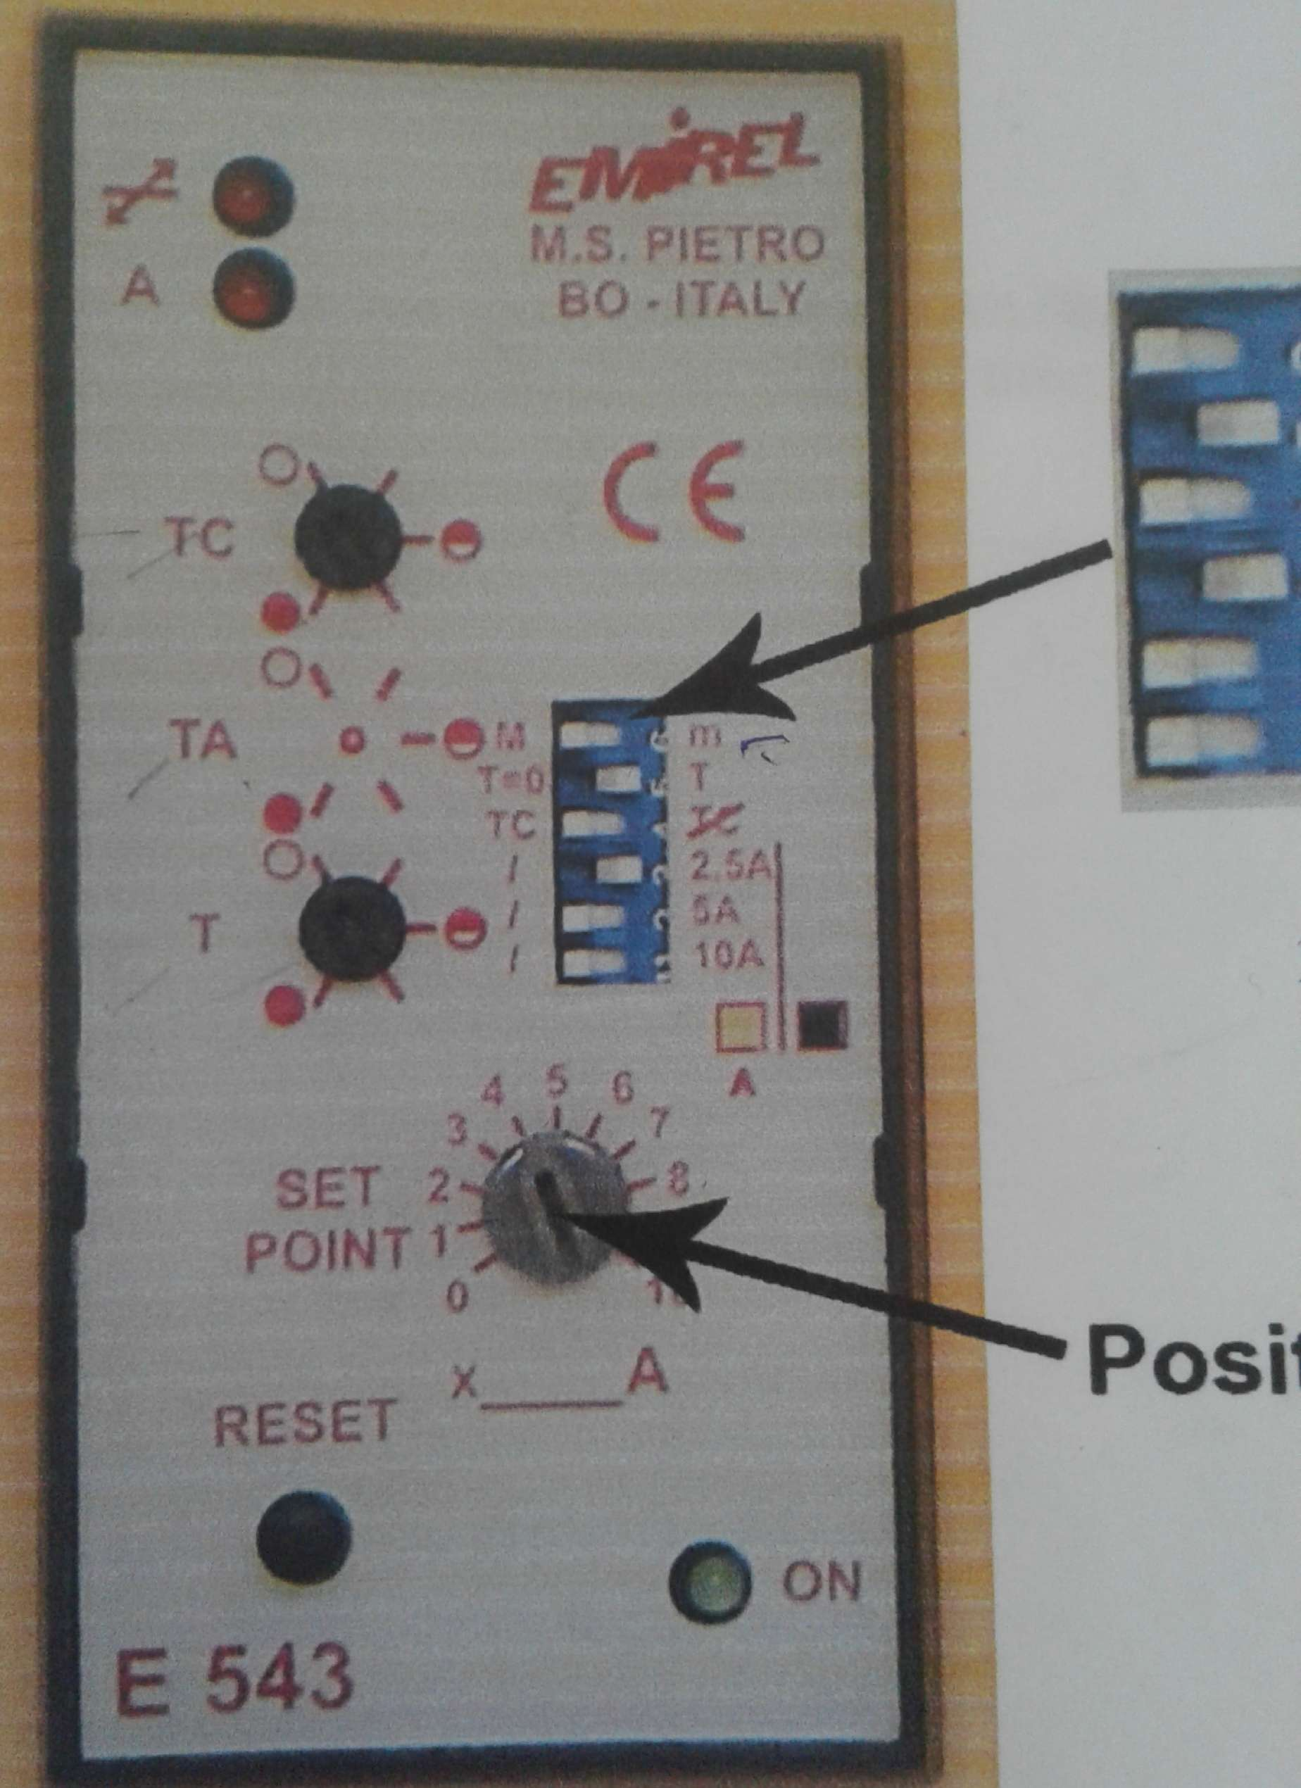

*Figure 1 : DTOC relay internal wiring Diagram*

**Circuit construction:**

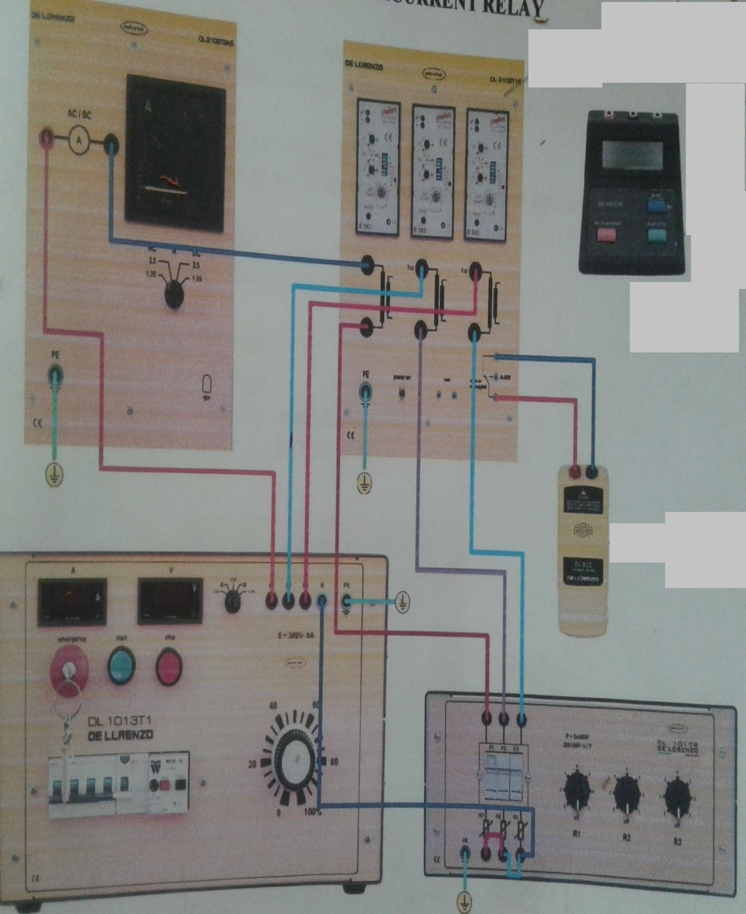

*Figure 2: Definite Time over Current Relay circuit*

**Procedure:**

**Procedure:**

* Connect circuit as shown in Fig 2.
* Set three phase power supply voltage 380V and relay is not in operation
* Starting from 0V slowly increase the value of three phase supply voltage until the overcurrent relay operates.
* Then slowly decrease the voltage until the relay release.
* Set the current set point A = 2A for the relays on the phases L2 and L3 and repeat the above procedure to verify it.
* Apply same procedure for different timer conditions

**Table 1:**

|  |  |  |  |  |  |  |
| --- | --- | --- | --- | --- | --- | --- |
| **Over Current conditions** | | | | **Under Current conditions** | | |
| **I** | **.25A** | **0.5A** | **0.75A** | **.25A** | **.5A** | **.75A** |
| **IO** | **0.45** | **0.75** | **1.17** |  |  |  |
| **Ir** | **0.4** | **0.72** | **1.05** |  |  |  |
| **Kr** | **1.125** | **1.041** | **1.1142** |  |  |  |

**Observation and Learning Outcomes:**